Choose a numeric variable in the Titanic data set and transform it using discretization, log, z-score, and min-max transformation.

Variable = Fare

**Discretization**

#categorizing fares into three subsections of costs

fare <- cut(titanic$Fare, breaks = c(1, 50 ,100,Inf), labels = c("low", "middle", "high"))

fare

[1] low middle low middle low low middle low low low low low low low low low low low low low low

**Log**

#log

titanic$logfare <- log(titanic$Fare)

plot(titanic$Fare, titanic$logfare)

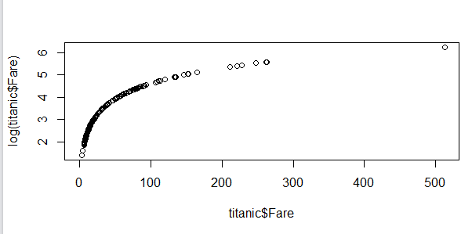

**Zscore**

#zscore

titanic$zscore <- scale(titanic$Fare, center = TRUE, scale = TRUE)

titanic$zscore

> titanic$zscore

[,1]

[1,] -0.502163137

**MinMax**

#minmax

minmax <- (titanic$Fare - min(titanic$Fare,na.rm=TRUE))/(max(titanic$Fare, na.rm = TRUE)-min(titanic$Fare, na.rm = TRUE))

minmax

[1] 0.014151058 0.139135735 0.015468570 0.103644297 0.015712554 0.016509502 0.101228858 0.041135660 0.021730754 0.058694293 0.032596229 0.051822149